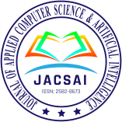

**E-ISSN:2582-8673**

Journal of Applied Computer Science &

Artificial Intelligence

Scholarly Peer-Reviewed Scientific Research Publishing Journal

**COPYRIGHT TRANSFER FORM**

**To,**

**The Editor-in-chief JACSAI, India**

Manuscript/Paper ID: 5070, Title of Manuscript: S-CART | WELCOME BUDDY

**Category:** Research [ ]

**\*CORRESPONDING AUTHOR**

Name: SHUBHANJAN BARAI, Affiliation: STUDENT, e-mail: [shubhanjanbarai18@gmail.com](mailto:shubhanjanbarai18@gmail.com), Mob: 7980192537

**OTHER AUTHOR(S)**

Name: RIYA DUTTA, Affiliation: STUDENT, e-mail: [riyadutta24556@gmail.com](mailto:riyadutta24556@gmail.com), Mob.: 8910037415 Name: SANA ASGAR, Affiliation: STUDENT, e-mail: sanaasgar4@gmail.com, Mob: 8335915949

Name: SAUNAK NANDI, Affiliation: STUDENT, e-mail: [saunaknandi021000@gmail.com](mailto:saunaknandi021000@gmail.com), Mob.: 6291683958

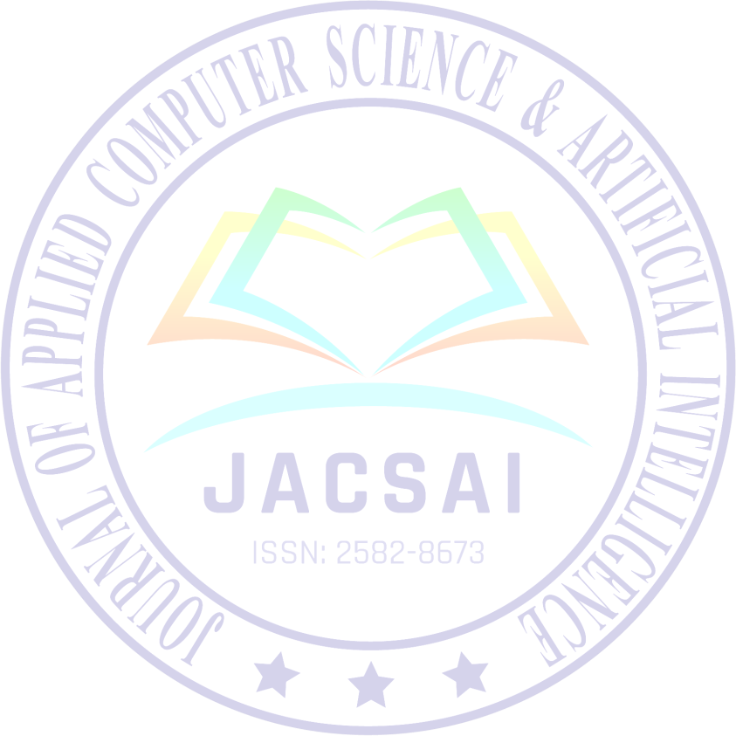

Name: SONALI BHATTACHARYYA Affiliation: ASSISTANT PROFESSOR, e-mail [sonali.bhattacharyya@jiscollege.ac.in](mailto:sonali.bhattacharyya@jiscollege.ac.in), Mob. 9831704373

Name: DR. PRANANTI RAKSHIT, Affiliation: ASSISTANT PROFESSOR, e-mail: pranati.rakshit@jiscollege.ac.in, Mob: 9434437490

**LICENSE AGREEMENT**

For the submission of a manuscript (mention type of the paper here): **Research Paper**

I hereby declare, on behalf of myself and my co-authors (if any), that:

1. The manuscript submitted is an original work and has neither been published in any other peer-reviewed journal nor is under consideration for publication by any other journal. Moreover, the manuscript does not contravene any existing copyright or any other third-party rights.
2. I am/we are the sole author(s) of the manuscript and maintain the authority to enter into this agreement and the granting of rights to **JACSAI** does not infringe any clause of this agreement.
3. The manuscript contains no such material that may be unlawful, defamatory, or which would, if published, in any way whatsoever, violate the terms and conditions as laid down in the agreement.
4. I/we have taken due care that the scientific knowledge and all other statements contained in the manuscript conform to facts and authentic formulae and will not if followed precisely, be detrimental to the user.
5. I/we permit the adaptation, preparation of derivative works, oral presentation or distribution, along with commercial application of the work.
6. No responsibility is assumed by **JACSAI**, its staff, or members of the editorial board for any injury and/or damage to persons or property as a matter of products liability, negligence or otherwise, or from any use or operation of any methods, products instruction, advertisements or ideas contained in a publication by **JACSAI**.

**COPYRIGHT TRANSFER**

Copyright to the above work (including without limitation, the right to publish the work in whole, or in part, in any forms) is hereby transferred to **JACSAI**, to ensure widest dissemination and protection against infringement. No proprietary right other than copyright is proclaimed by **JACSAI**.

**Under the Following Conditions: Attribution**

* 1. The services of the original author must be acknowledged;
  2. In case of reuse or distribution, the license conditions must be clarified to the user of this work;
  3. Any of these conditions can be ignored with the consent of the author.

**Sign Here For Copyright Transfer**: I/We hereby certify that I/We am/are authorized to sign this document either in my own right or as an agent of my employer and have made no changes to the currently valid document supplied by **JACSAI**.

DATE: 23/06/2022

Author/s Signature and Date [Corresponding Author (in case of many authors)]

Typed or Printed Name: SHUBHANJAN BARAI

**Note:** Sign the form, scan it, and then save the scanned file in PDF format with the name “**Copyright Form for Paper ID <***write here your paper ID***>.pdf**” and send it to [**submission.jacsai@gmail.com**](mailto:submission.jacsai@gmail.com)along with the final paper and required documents.

Note: This agreement is to be signed by at least one of the authors who have obtained the assent of the co-author(s) where applicable. Your article will not be published unless the duly signed scanned copyright form has been received.